COMPUTER PROGRAMING

ASSGINMENT (NO-5)

Name: Kakavakam Jaswanth Sai

Roll no: CH.EN.U4CSE20130

Section: CSE-B

Subject code: 19CSE102 LAB

Question – 1:

You have to accept two numbers and output sum and absolute difference using pointers.

C-program:

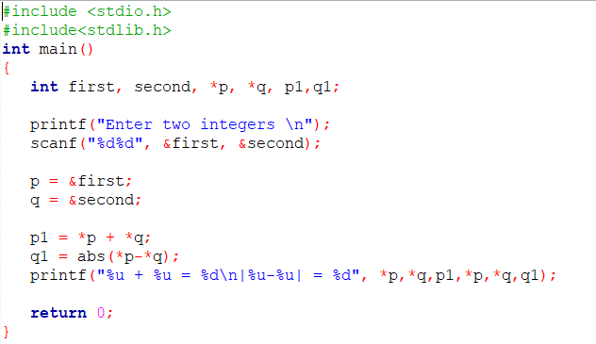

Output:

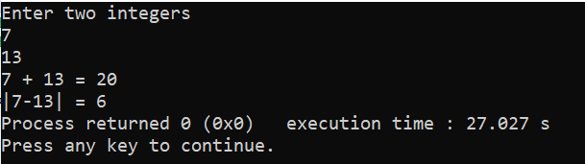

Question – 2:

Input a triplet of three numbers (a, b, c) and output 1 if they are either in strictly increasing (a>b>c) or decreasing (a<b<c) order 0, otherwise.

C-program:

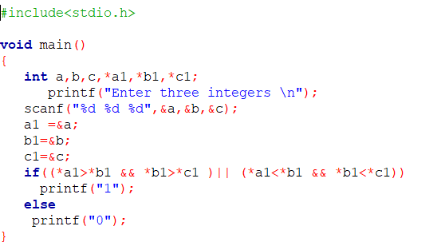

Output:

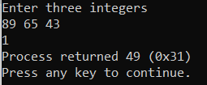 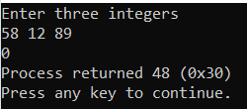 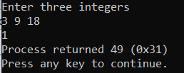

Question – 3:

Input a sequence of non-negative floating point numbers terminated by a "-1".we have to out put the moving average of the sequence. the output should be printed correct to one digit after decimal.

C-program:

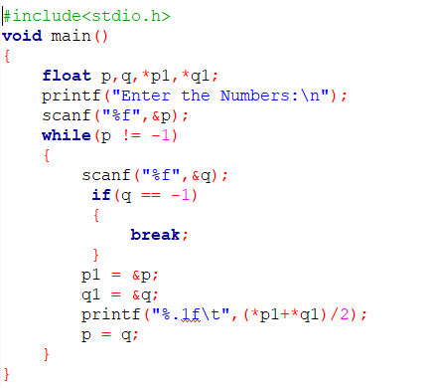

Output:

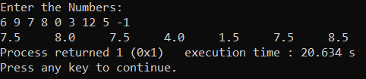

Question – 4:

Reverse a string without 0 using pointers.

C-program:

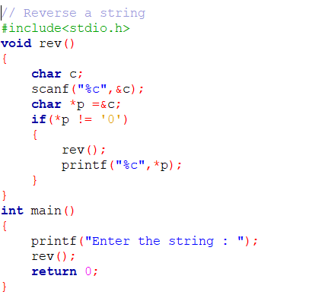

Output:

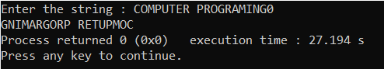

Question – 5:

You are given a sorted (either in increasing or decreasing order) sequence of positive numbers, ending with a "-1". you have to output 1 if there are at least three distinct numbers in the sequence. otherwise output 0.

C-program:

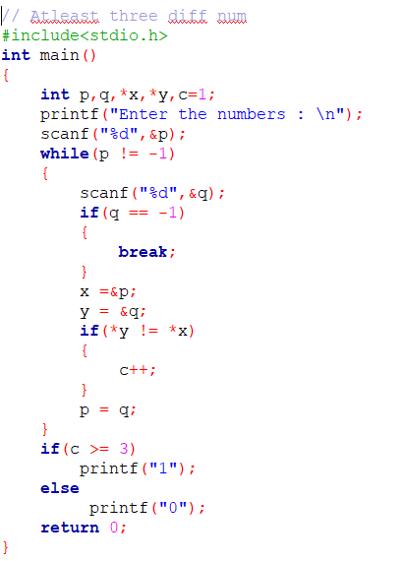

Output:

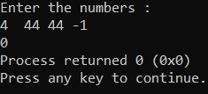 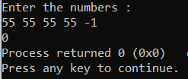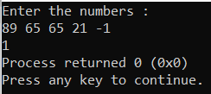

Question – 6:

You have to output the second largest element of the sequence. if there is no second largest element in the sequence output zero.

C-program:

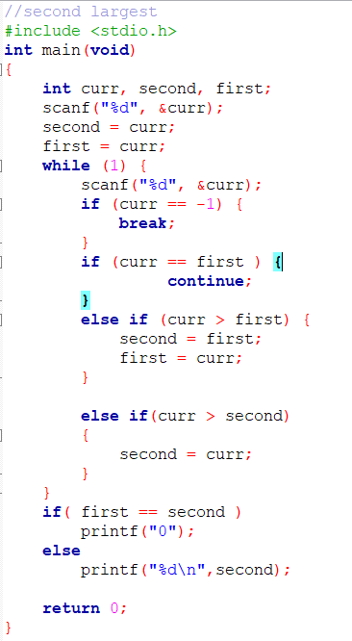

Output:

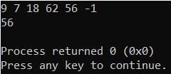 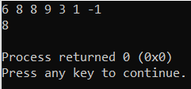

Question – 7:

Given two arrays of integers output the largest number in the first array not present in second one.

C-program:

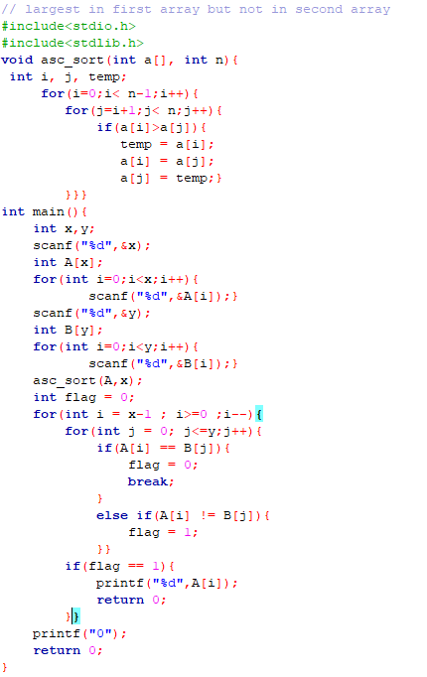

Output:

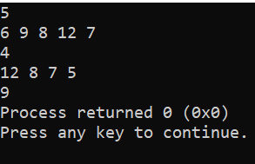

Question – 8:

A string is passed as input. the program must find the vowels present in the string and print them reverse.

C-program: 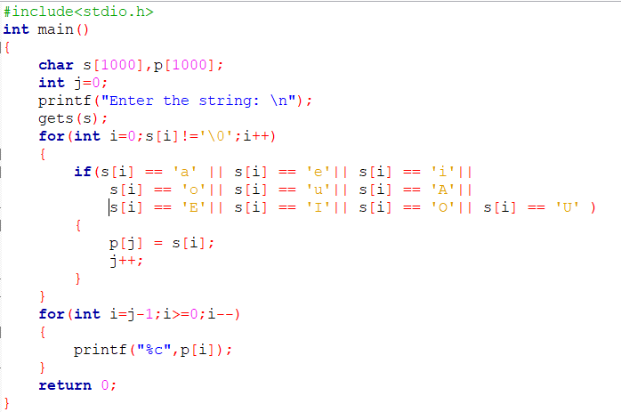

Output:

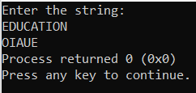

Question – 9:

You should accept a string value and prints the last occurring vowel.

C-program:

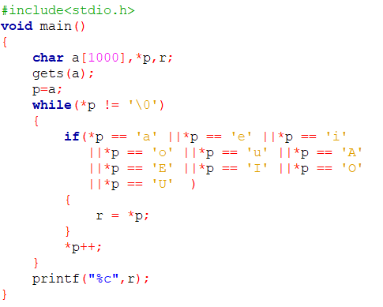

Output:

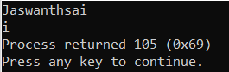

Question – 10:

Sort a Word.

C-program:

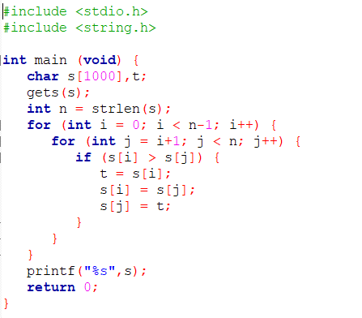

Output:

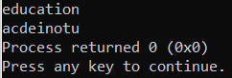

Question – 11:

Given a list of numbers L, write a program to prepare a new list L1 from L such that the ith element in L1 = ith element in L+5.

C-program:

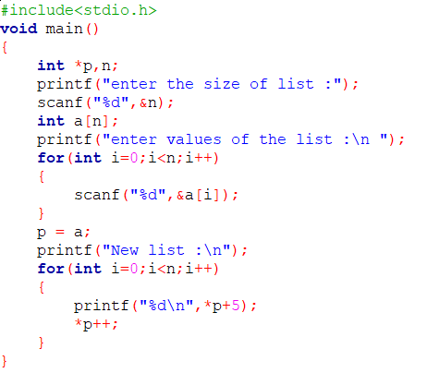

Output:

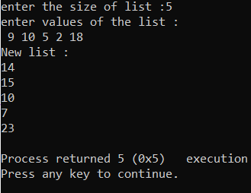

Question – 12:

Print the array of string.

C-program:

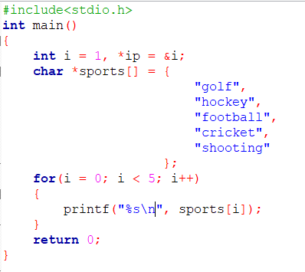

Output:

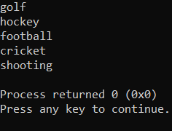

Question – 13:

Get the name ,roll no, marks of 5 subjects of a student and print Total Average and grade using structures.

C-program: 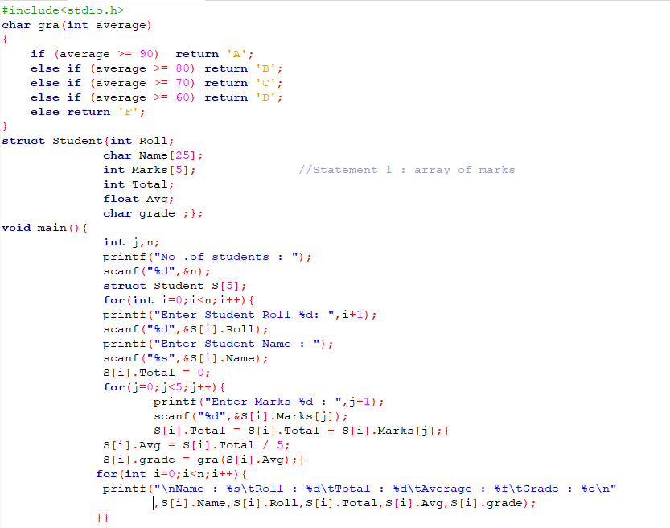

Output:

